**Invitation  
World Championship STRATEGO 2018  
23 till 26 Augustus, Naarden-Vesting (The Netherlands)**

**---------------------------------------------------------------------------------------------------------------------------  
Dear Strategist,  
At the end of August The World Championship of STRATEGO will go to The Netherlands! After earlier Dutch Editions in Rotterdam, Maastricht & Haastrecht, the 21st World Championship is held in Naarden-Vesting. This year the world titles are being fought for between canals, gates and tunnels that make up Naarden-Vesting, one of the best kept fortress cities in Europe. If you want to hear a real canon, make sure you are there Thursday 23 August at 13:15 for the official opening shot.  
  
The World Championship is open for all participants. Young and old, starters and experienced players, everyone will meet opponents of a sort of similar level. The World Championship will be fun, exciting games, and the chance to reach eternal fame. The World Championship is the ideal event to meet STRATEGO friends from all over the world to enjoy the game.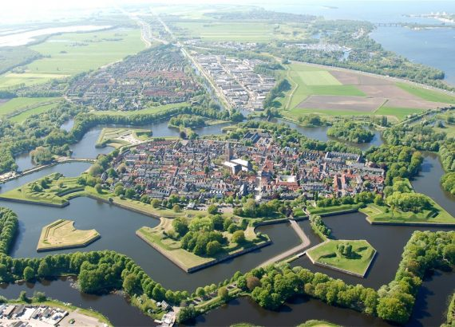 Stratego is one of the most popular board games in history. Worldwide over 20 million copies are sold and generations have grown up playing this great game. Recently Jumbo made a retro version of STRATEGO with the well known towers as pieces, but with a seductive spy.   
  
In this invitation you will find all the information regarding the WC STRATEGO including the detailed playing schedule and the tournament rules. We are looking forward to your participation at the biggest STRATEGO event of the year at this unique location!  
  
See you in Naarden-Vesting,**  **Tim Slagboom, Pim Niemeijer en Dennis Baas  
Organisation Team WC STRATEGO 2018**

**1. Venues  
 *The Fortress Museum*The kick off is on Thursday 23 August with the WC Barrage at theVestingmuseum (address: Westwalstraat 6, 1411 PB Naarden). Who can stay focussed while surrounded by cannons? At about 13.15 hours the official opening is done by soldiers in uniforms of 1815 with a cannon shot!**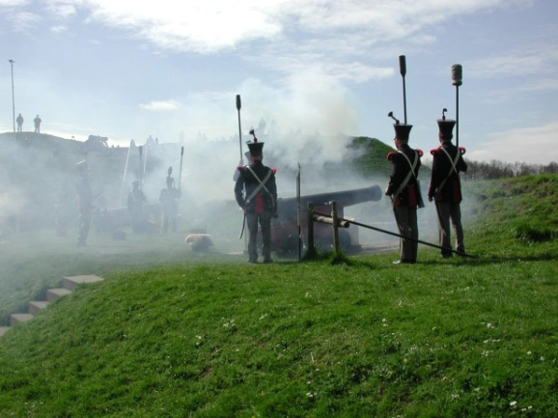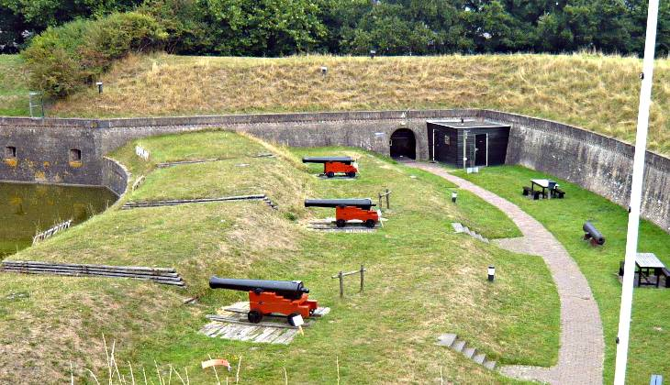 ***The Arsenal*The WC continues in the historic Arsenaal (address: Kooltjesbuurt 1, 1411 RZ Naarden) where on Friday   
24 August, Saturday 25 August and Sunday 26 August the WC Classic, WC Junior players, WC Country teams and Open Naarden will take place.  
  
Both locations have plenty of opportunities for eating and drinking. It is not allowed to consume your own food / drinks at the locations. Additionally the city of Naarden-Vesting has a wide selection of eating and drinking locations at walking distance from the play locations.**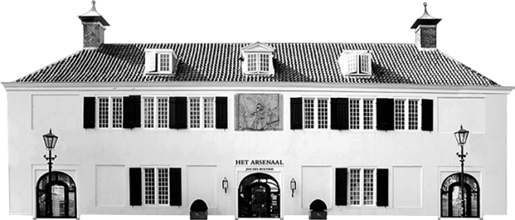 ***Travel information and parking*By car Naarden-Vesting is very easy accessible. The city is central in The Netherlands and is close to both Amsterdam (25 km east) and Utrecht. Major highways connect almost directly to Belgium and Germany.**

**Parking spots can be found at Parking ‘Nieuwe Molen’. There are over 200 free spots within walking distance of the world championship locations.  
  
There are various public transport options, the last part of the trip will always be by bus. This can be direct from Amsterdam or via Dutch Railways stations Naarden-Bussum of Weesp. Total travel time from Amsterdam Central Station is roughly 50 minutes en from Utrecht Central roughly 40 minutes. Check Dutch travel info at** [**www.9292ov.nl**](http://www.9292ov.nl) **for more details (information in English or Dutch).**

**The best way to get to Naarden-Vesting from Amsterdam Schiphol Airport is by railway to Naarden-Bussum station and by bus after. We will most likely run some transport services to make the transport a bit smoother. More details about this will follow. If you have specific questions please ask the team.  
  
2. Staying overnight and sights to see  
 *Staying overnight*Within the walls of Naarden-Vesting there are limited number of hotels. The WC organisation team recommends the following hotels nearby.  
  
NH Naarden – 2km from Naarden-Vesting – WC reachable by car, public transport or 30 mins walk  
NH Bussum (Jan Tabak) – 2km from Naarden-Vesting – WC reachable by car or 30 mins walk  
Bastion Hotel Bussum – 4km van Naarden-Vesting – WC reachable by car  
Boooking can be done amongst other via** [**www.nh-hotels.nl**](http://www.nh-hotels.nl)**,** [**www.bastionhotels.com**](http://www.bastionhotels.com) **or** [**www.booking.com**](http://www.booking.com)**.  
  
In addition the website** [**www.airbnb.nl**](http://www.airbnb.nl) **also offers various good options around Naarden-Vesting. To book you need to make an account with them.**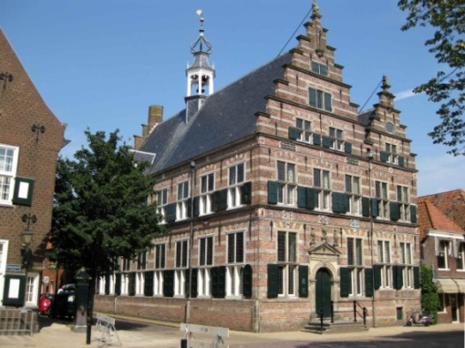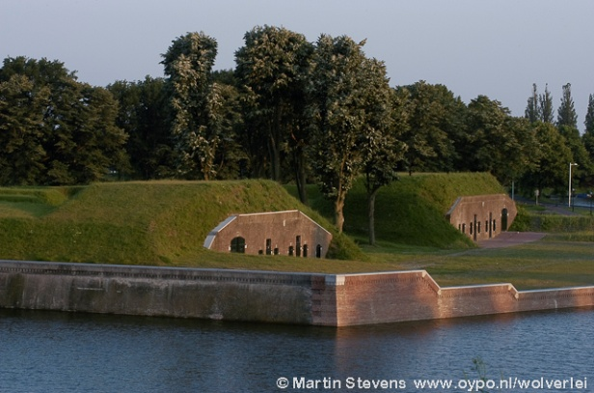 ***Sights to see*For the players that are considering to make a (short) holiday around the World Championship, on** [**www.stratego.com**](http://www.stratego.com) **is an overview of the sights in Naarden-Vesting / Amsterdam and surroundings:** [**Overview**](http://forum.stratego.com/topic/358223-wc-2018-tips-and-things-to-know-about-the-netherlands/)**.  
  
3. The Tournament  
  
*Main program*Thursday 23-08: Official Opening WC 2018 with cannon shot and WC Barrage (Fortress Museum)  
Friday 24-08: WC Classic round 1 till 5 (Arsenal)  
Saturday 25-08: WC Classic round 6 till 10 + WC JUNIOR players (Arsenal)  
Sunday 26-08: WC Country teams + Naarden Open Tournament (Arsenal)  
  
*Entry fees*Early registration leads to a discount. This can be done untill 31-07-2018 via de WC2018 Facebook page** [**www.facebook.com/events/1677284869028262/**](http://www.facebook.com/events/1677284869028262/) **or by sending an email to** [**strategomaster@hotmail.com**](mailto:strategomaster@hotmail.com) **including full name, nationality and date of birth. The actual payment can be made at the start of the tournament.  
 Normal price Reduced rate (pre-registered)  
WC BARRAGE: € 7,50 € 5,00   
WC CLASSIC: € 25,00 € 20,00  
WC JUNIOR PLAYERS: € 7,50 € 5,00   
WC COUNTRY TEAMS: FREE FREE  
NAARDEN OPEN TOURNAMENT: FREE FREE  
Prizes  
WC BARRAGE: Cups for nr 1 till 3   
WC CLASSIC: Cups for nr 1 till 10  
WC JUNIORS: Cups for nr 1 till 5   
WC COUNTRY TEAMS: Gold, Silver and Bronze medals for place 1, 2 ,3  
OPEN NAARDEN: Cups for nr 1 till 3  
All players in the WC Classic and WC Juniors will get a special WC souvenir.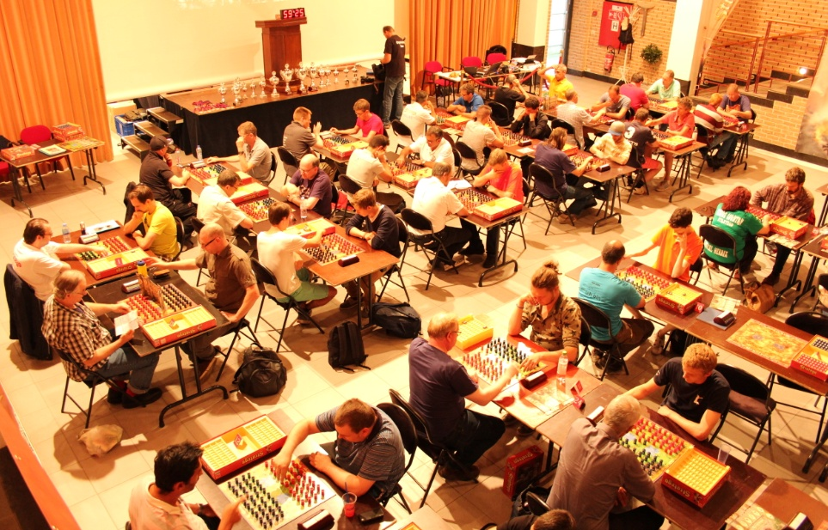 4. Program per day  
 *Thursday 23 August, day 1*WC Barrage  
11:30 – 12:30 Meeting WC Organisation Team**

**12:30 – 13:15 Arrival and registration of players  
13:15 – 13:30 Official opening WC with cannon shot and group photo.  
 Explaining the tournament setup and rules  
  
13:35 – 14:00 round 1 16:10 – 16:35 round 6   
14:00 – 14:25 round 2 16:35 – 17:00 round 7  
14:25 – 14:50 round 3 17:00 – 17:25 round 8  
14:50 – 15:15 round 4 17:25 – 17:50 round 9  
15:15 – 15:40 round 5 17:50 – 18:15 round 10  
15:40 – 16:10 Break 18:20 – 18:30 Awards Ceremony  
  
  
  
 *Friday 24 Augustus, day 2***

**WC Classic (rounds 1 - 5)**

**08:30 – 09:30 Meeting WC Organisation Team**

**09:30 – 10:30 Arrival and registration of players**

**10:35 – 11:00 Opening and introduction WC org team  
 Explaining the tournament setup and rules**

**11:00 – 11:20 Group photo  
  
11:30 – 12:35 round 1**

**12:40 – 13:45 round 2**

**13:45 – 14:45 Lunch break**

**14:45 – 15:50 round 3**

**15:55 – 17:00 round 4**

**17:00 – 17:15 Short break**

**17:15 – 18:20 round 5**

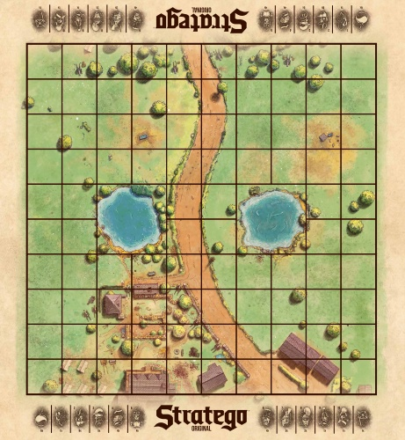

***Saturday 25 August, day 3***

**WC Classic (rounds 6 - 10)**

**09:30 – 10:30 Meeting WC Organisation Team**

**10:30 – 10:55 Players arrive and pairing round 6**

**11:00 – 12:05 round 6**

**12:10 – 13:15 round 7**

**13:15 – 14:15 Lunch break**

**14:15 – 15:20 round 8**

**15:25 – 16:30 round 9**

**16:30 – 16:45 Short break**

**16:45 – 17:50 round 10**

**18:20 – 18:45 Awards Ceremony**

**WC Juniors  
09:30 – 10:00 Arrival and registration of players**

**10:00 – 10:30 Opening en introduction WC org team  
 Explaining the tournament setup and rules**

**10:30 – 10:45 Group photo**

**11:00 – 11:45 round 1**

**11:50 – 12:35 round 2  
12:40 – 13:25 round 3**

**13:25 – 14:25 Lunch break**

**14:25 – 15:10 round 4**

**15:15 – 16:00 round 5  
16:00 – 16:15 Short break**

**16:15 – 17:00 round 6**

**17:05 – 17:50 round 7**

**18:20 – 18:45 Awards Ceremony**

***Sunday 26 August, day 4***

**WC Country Teams**

**09:30 – 10:00 Meeting WC Organisation Team**

**10:00 – 10:30 Arrival of qualified players and group photo**

**10:30 – 16:10 WC Country Teams (the exact schedule depends on the number of participating countries)**

**16:10 – 16:30 Awards Ceremony  
  
Open Naarden  
09:30 – 10:00 Meeting WC Organisation Team   
10:00 – 10:30 Arrival and registration of players  
10:45 – 11:40 round 1  
11:45 – 12:40 round 2  
12:40 – 13:10 Lunch break  
13:10 – 14:05 round 3  
14:10 – 15:05 round 4  
15:10 – 16:05 round 5  
16:10 – 16:30 Awards Ceremony  
  
5. Tournament Rules  
 *Rules***

**- At the WC the original Jumbo Game rules are used, the ISF game Rules and the ISF tournament rules  
- The ISF rules can be found at** [**http://isfstratego.kleier.net/rulreg.html**](http://isfstratego.kleier.net/rulreg.html) **and will be available at the WC**

**- Every players that knows the base rules of STRATEGO can participate in the tournament. The most important rule about repeated moves will be explained at the start of the tournament. We recommend visiting a live tournament or practice online at** [**www.stratego.com**](http://www.stratego.com)**.**

**- All events are lead by the WC Organisation Team. Their decisions are binding.**

**- Public is welcome to all tournaments. We do ask to do not distract the players or influence the game outcomes.**

***Tournament rules***

**- The WC Barrage, WC Classic and Open Naarden all count for the International STRATEGO Rating:** [**http://www.kleier.net/rating/general/index.php**](http://www.kleier.net/rating/general/index.php)**.**

**- The WC will be played according to the Swiss Perfect system. This means that every player players all rounds of the tournament. (no Knock-out system) The Classic tournament is Friday and Saturday. You will play against opponent each round with similar tournament strength.  
- Seniors and Juniors play during all events with the most recent version of the classic European pieces (see picture).  
- Everyone born in 2004 or later is a Junior player.  
-The best 4 Classic players of each country qualify for the WC Country Teams.  
- If one or more qualified players do not participate, the nr 5 qualifies, then the nr 6, nr 7 etcetera. Every Country Team must have at least 3 players.**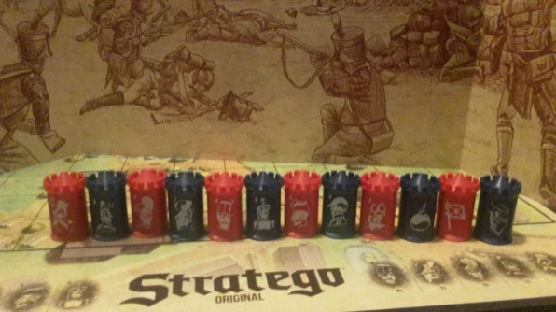

***Clock times*- During the WC we use the Bronstein clocks for all games. Only the Junior Players may decide to play without clock, if both players agree.  
- Play time for WC Barrage = 1 min setup time+ 10 minutes play time. 3 sec per move are free.  
 Start time on clock 02.03. After 10 minutes the game ends in a draw.  
- During the WC Barrage every round 2 games of max 10 minutes are played, where the score of each game (6, 3 of 1 points) of each game is taken into the total score.  
- Play time for WC Classic = 5 min setup time + 60 min play time. 4 seconds per move are free.  
 Start time on clock 16.04. After 60 minutes the game ends in a draw.  
- Play time for WC Junior Players= 5 min setup time + 50 minutes play time. 4 seconds per move are free.  
 Start time on clock 12.04. After 50 minutes the game ends in a draw.  
- Play times for WC Country Teams and Open Naarden are the same as WC Junior Players  
   
6. Contact details  
  
*WC Organisation Team*For more information contact one of the members of the organisation team:  
Tim Slagboom E-mail:** [**tim.slagboom@gmail.com**](mailto:tim.slagboom@gmail.com) **Tel.: 0031-683217499  
Pim Niemeijer E-mail:** [**strategomaster@hotmail.com**](mailto:strategomaster@hotmail.com) **Tel.: 0031-630209532  
Dennis Baas E-mail:** [**dbaas@chello.nl**](mailto:dbaas@chello.nl) **Tel.: 0031-627540373  
  
*Day organisation*During the WC the following people will be able to answer your questions:  
Roseline de Boer Head Referee WC Classic WC Junior players + WC Country teams  
Mark Coenen Referee WC Classic + Open Naarden  
Jeroen Geelhoed Referee WC Junior Players**

**Peter-Jan van den Enden Computer WC Classic + WC Junior players  
Tim Slagboom Referee + Computer WC Barrage**